How to book a room using Outlook.
- Open Outlook.
- Click on Calendar in the bottom bar and find the date you want to reserve a room on.
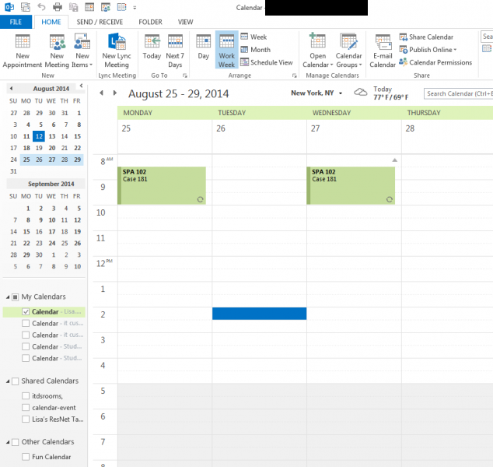
- Next, find the specific start time under that date. Click on it.
- Click the "New Meeting" button on the ribbon menu at the top right.
.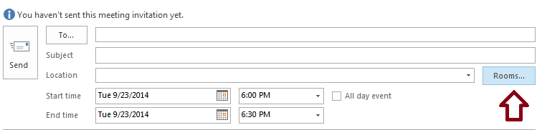
- Beside the Location box, click the "Rooms..." button
- Find your room on the room list.
- Once you have located your room, highlight it and click "OK".
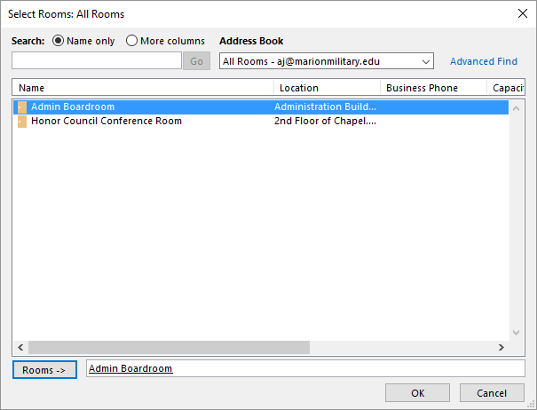
- Double check to make sure that your date, start, and ends times are correct.
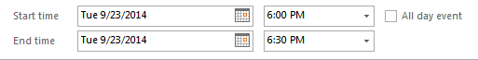

- You can check to be sure that the room is open for your date/time request by clicking the Scheduling Assistant link. Any conflicts will show up there as a dark blue bar. The image below is an example of what it would look like in Scheduling Assistant if there were a conflict
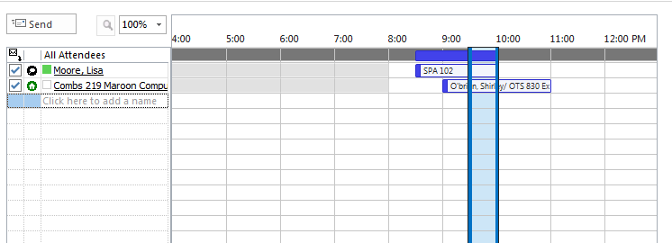
- In the subject line please type your meeting or training name (example: Student Affairs RA training).
- Click the "Send" button.
- You will receive an automatic response and the room request will appear on your calendar. This is to let you know that your request was successful.

