How to view the MMI Master Calendar in Outlook
- In Calendar view
- Click "Folder"
- from the ribbon click "Open Calendar"
- from the dropdown click "From Address Book..."

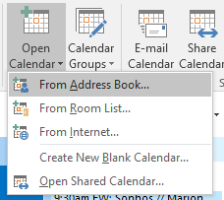

- Select “Global Address List” from the from the dropdown
- Type mmi master calendar in the search box
- Select MMI Master Calendar from the list and then click the Calendar button
- Click “OK” to add the calendar to outlook.
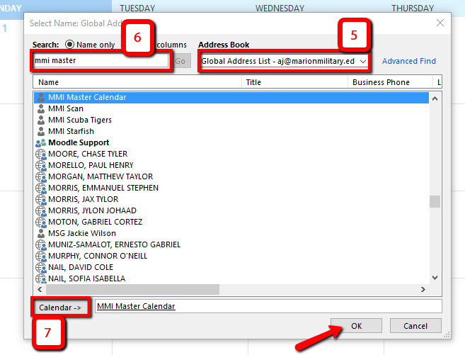
The MMI Master Calendar will appear under “Shared Calendars” in the left-hand side of your calendar view.

