A Tradition Since 1842
MARION MILITARY INSTITUTE
THE MILITARY JUNIOR COLLEGE OF ALABAMA
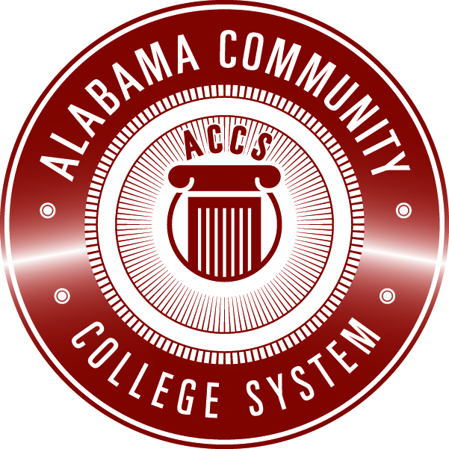
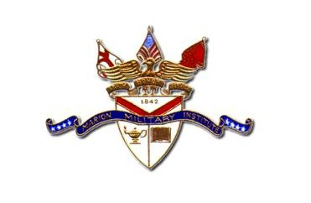
Trip Report

Date:

Participants:

Subject (with dates):

Purpose:

Itinerary:

Highlights:

Conclusions:

